Charlotte Mason Mentoring
A House of Education for Homeschooling Mothers:
Centered on the Gospel of Christ - Rooted in Scientific Research - For the Children’s Sake
The House of Education was a training school in Ambleside, England for governesses and others learning how to teach Charlotte Mason’s Methods in the P.N.E.U. Schools and in private homes. Charlotte Mason provided hands on training and an education for these young women so they were equipped to train children.
Our Lord, Jesus, had disciples that he mentored and trained so they were equipped to reach their generation with the Good News.
It is my desire to see parents in our generation discipled and equipped to train up their children in the Knowledge of God. Therefore, I am offering a summer of Charlotte Mason Mentoring in which small groups of Mothers will gather to practice the art of leading their children into Knowledge of God, Knowledge of Man, and Knowledge of the Universe.
-------------------------------------------------------------------------------------------
These sessions will involve your children. I want you coming away from our time practiced and feeling confident that you can implement these ideas in your home!
The first hour you will gather with a small group of women to learn about Mason’s methodology and philosophy of education. During this time, your children will participate in planned activities with my oldest daughter who will guide them through a simple handicraft, Hymn, Art Study, snack, Folk song, poem, and dance or outdoor games. Following this time, we will gather with our children for the second hour and do a few practice lessons together where you will all have an opportunity to implement what you have learned and practice with one another’s children!
-------------------------------------------------------------------------------
Summer 2016 Schedule and Themes
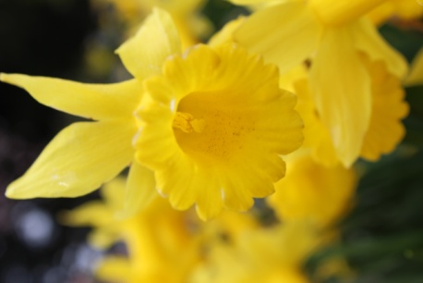
Thursday, June 30, 9-11 am: Introduction to Mason and Getting Started Q and A
Friday, July 15, 9-11 am: Living Books and Narration
Wednesday, July 20, 1-3 pm: What do I do this fall?? Curriculum Helps
Tuesday, August 9, 9-11 am: What do we do for Language Arts?
Monday, August 22, 1-3 pm: History, Geography, and Bible
Friday, September 9, 2-4 pm: Prayer for a new season and Q & A

“Of the three sorts of knowledge proper to a child, the knowledge of God, of man, and of the universe,––the knowledge of God ranks first in importance, is indispensable, and most happy-making. Mothers are on the whole more successful in communicating this knowledge than are teachers who know the children less well and have a narrower, poorer standard of measurement for their minds.” CM Volume 6

Registration Information
You may either print and mail in this registration to Heidi Buschbach - 3000 Leyland View, Woodbury, MN 55125 or you may register online for these events at: http://forthechildrenssake.weebly.com/charlotte-mason-mentoring.html
You may attend any or all.
Space is limited to 4 women (and their children) per session.
Cost for each session is $8 per family to cover the cost of a snack and supplies. You may pay when you arrive the day of your session with cash or check.
If your child has any food allergies, please alert me on your registration form. Snacks will be gluten free.
Name: ______________________________
Date/s you wish to attend: ____________________________
Number of Children:________________________________
Names and Ages of Children:____________________________________
_________________________________________________________
Allergies?:______________________________________________
E-mail: ________________________________________________
Phone number:_________________________________________________
Address: ______________________________________________________
Please also list any particular concerns you have or things you would like to learn at your session!

